ISC/22/SWO-WG/04

**U.S. SWORDFISH FISHERIES IN**

**THE NORTH PACIFIC OCEAN**[1]

Russell Y. Ito

Pacific Islands Fisheries Science Center

National Marine Fisheries Service, NOAA

Honolulu, Hawaii 96822 U.S.A.

and

Yuhong Gu

Southwest Fisheries Science Center

National Marine Fisheries Service, NOAA

La Jolla, California 92038 U.S.A.

**November 2022**

**U.S. SWORDFISH FISHERIES IN**

**THE NORTH PACIFIC OCEAN**

Russell Y. Ito

Pacific Islands Fisheries Science Center

National Marine Fisheries Service, NOAA

Honolulu, Hawaii 96822 U.S.A.

and

Yuhong Gu

Southwest Fisheries Science Center

National Marine Fisheries Service, NOAA

La Jolla, California 92038 U.S.A.

**INTRODUCTION**

The United States is a major harvesting and consuming nation for swordfish (*Xiphias gladius*). U.S. fisheries in the Atlantic Ocean, Gulf of Mexico, and Pacific Ocean harvested 1,970 metric tons (mt) in 2021 (NMFS, Office of Science and Technology, 2022). Of this total, 766 mt (39%) were taken by the U.S. fisheries for swordfish in the North Pacific Ocean. This report summarizes historical trends and recent developments for these fisheries.

**1. FISHERIES AND CATCHES**

U.S. swordfish fisheries in the North Pacific Ocean was categorized by the major gear types employed (harpoon, drift gill net, and longline). Harpoon fishing for swordfish in California is the oldest of the three, dating back to the early 1900’s (Coan et al., 1998). This fishery primarily supplied the local market for swordfish until the late 1970s. Harpoon catch peaked at 1,699 mt in 1978, subsided to a more typical level the following year, gradually decreased to a record low level in 2012 and 2015 and has remained low with 7 mt caught in 2021 (Fig. 1). The California drift gill net fishery began in 1980 and became the largest U.S. swordfish fishery in the North Pacific Ocean the following year. Catch by this fishery peaked at 2,990 mt in 1985 then trended down to a record low 13 mt in 2021. Since 2014, the U.S. west coast harpoon and gillnet fisheries targeting swordfish have been modifying their gear and using “deep-set buoy gear” to maximize economic benefits while minimizing non-target catch. In 2021, 19 vessels participated in the buoy gear fishery and caught 49 mt of swordfish in the eastern Pacific Ocean. Shallow-set longline fishing for swordfish in Hawaii began in 1988 and grew rapidly. The shallow-set fishery, along with incidental catches of swordfish by the deep-set longline fishery for tunas, became the largest U.S. fishery in the North Pacific Ocean for swordfish by 1990 with catches peaking at 5,936 mt in 1993. Longline catches of swordfish decreased in the following years but it still is the largest U.S. fishery for swordfish in the North Pacific Ocean with catch at 690 mt in 2021. Some shallow-set longline vessels migrate between Hawaii and west coast states depending on the seasonality of swordfish and fishing conditions.

**California Harpoon Fishery**

The California harpoon fishery targeting swordfish began in the early 1900s, with catch recorded since 1918. Participation in the harpoon fishery was highest up through the mid-1980s and decreased slowly thereafter (Fig 2). There were 11 vessels fishing in 2021, down from 15 vessels in 2020**.**

The fishing area typically ranges from San Diego to Point Conception. Most fishing effort occurs within the southern California Bight. The fishery usually begins in June in waters off San Diego, peaks in July or August, and ends November.

Harpoon catch of swordfish varied substantially up through the mid-1980s, peaking at 1,699 mt in 1978. Swordfish landings by the California harpoon fishery declined in subsequent years. The swordfish catch was at record lows between 2012 and 2015 and was 7 mt in 2021 (Table 1).

Harpoon catch-per-unit-effort (CPUE) is calculated from logbook data and measured as number of fish per day. One important factor in the harpoon fishery is the use (or lack thereof) of spotter aircraft. Swordfish CPUE for vessels using spotter aircraft was about four times that of vessels that had no aircraft assistance. Aircraft were not used from 1980 through 1983. In general, the trend for swordfish CPUE with and without aircraft assistance was similar (Fig. 3). Both nominal CPUE time series had a high degree of variability with no clear trend. Harpoon swordfish CPUEs were at record lows in 2013 then increased the following three years. There was no CPUE for vessels with aircraft assistance in 2021 while CPUE for operations without aircraft assistance was 1.2 fish in 2021.

**California Drift Gill Net Fishery**

The California large-mesh drift gill net fishery began in the late 1970s. Swordfish, common thresher shark (*Alopias vulpinus*) and shortfin mako shark (*Isurus oxyrinchus*) were the targeted species (Hanan et al., 1993). The gill net fishery is seasonal with fishing activity beginning in the latter part of one year continuing into the following year. Swordfish catch by this fishery was initially low, but increased in the early 1980s when regulations were changed to allow for a greater level of catch. The number of active drift gill net vessels peaked at 220 during 1985-1986 then decreased gradually to a record low 6 vessels in 2020-2021 (Fig. 4).

Drift gill net fishing effort is concentrated in the Southern California Bight (waters from Point Conception to Mexico), but can extend beyond San Francisco to Oregon. The fishing effort occurs within the 200 mile U.S. EEZ. The drift gill net fishery begins in May and lasts about 10 months with peak swordfish catches in October and November.

Swordfish catch by the drift gill net fishery increased from 160 mt in 1980 to 2,990 mt in 1985. Since then, swordfish catches fluctuated on a decreasing trend to a record low 13 mt in 2021 (Table 1).

Drift gill net CPUE was relatively steady from the 1983-1984 season through 2000-2001 and showed much more variation in the following years. The recent trend for gill net CPUE was increasing from 2010-2011, reached a record 11.5 fish per set in 2016-2017 and was 1.97 fish per set in 2020-2021 (Fig. 5)

**U.S. Longline Fishery**

The fishing vessel *Magic Dragon* came to Hawaii and introduced shallow-set longline techniques for swordfish from Florida in 1988 (Ito et al., 1998). This segment of the longline fishery eventually grew and established Hawaii as a major domestic producer of swordfish. The number of Hawaii-based longline vessels increased rapidly from 37 vessels in 1987 to 141 vessels in 1991 as U.S. longliners from the Gulf of Mexico and the Atlantic swordfish fisheries joined the Hawaii-based longline fishery (Fig. 6). A federal moratorium was implemented in 1991 to limit the number of longline permits at 167 in light of this rapid expansion. Vessel participation never reached the limit. The moratorium on permits was replaced with a limited entry program in 1994 which capped participation in Hawaii’s longline fishery at 164 vessels. Vessel activity ranged from 100 to 143 vessels up through 2015, with 141 active longline vessels in 2016. Seventeen U.S. longline vessels went shallow-set longline fishing for swordfish in 2021, up slightly from 14 in 2020.

The U.S. shallow-set longline fishery operating out of Hawaii was heavily regulated in 1999-2001 and prohibited from 2002 through early 2004 due to concerns with sea turtle interactions. Some of these vessels migrated to California to continue fishing for swordfish while other longline fishermen stayed in Hawaii and converted to deep-set longline fishing for tuna. Shallow-set longline fishing from Hawaii was reopened in April 2004 under new regulations promulgated by NOAA Fisheries. The new regulations were enacted to minimize interactions between longline gear and sea turtles included notifying NOAA Fisheries of an intent to deploy shallow-set gear before any such trips, 100 percent observer coverage on shallow-set trips, use only circle hooks and mackerel or mackerel-type bait, begin setting gear one hour after sunset, devices such as a dehooking device and large dip nets to help reduce injuries to sea turtles and a limit of 2,120 shallow sets per year for eligible Hawaii longline limited access permit holders. The limit on the number of shallow sets was removed in 2009. The rules first established a limit on the numbers of interactions between shallow-set longline gear and leatherback (*Dermochelys coriacea*) and loggerhead (*Caretta caretta*) sea turtles. A mandatory fishery closure was enacted when the respective limit for either species was reached. Although shallow-set longline from Hawaii was reopened in March 2004, 2005 was the first complete year this fishery operated under the new guidelines. Since sea turtle interaction limits were implemented, the shallow-set longline fishery closed on four occasions, March 2006 (loggerhead interaction limit), November 2011 (leatherback interaction limit), May 2018 (loggerhead interactions and Court order) and March 2019 (loggerhead interaction limit). The loggerhead annual interaction limit was changed to a trip limit in September 2020. The shallow-set longline fishery did not reach either turtle interaction limit and remained open in 2020 and 2021.

The U.S. longline fishery in the north Pacific Ocean ranged from 10oN to 40oN latitude and from 125oW to 175oW longitude in 2021. The total range since 1991 extended from the equator to 50oN latitude and from 130oW to 175oE longitude. Effort by the U.S. longline fishery increased to a record 66.3 million hooks set in 2021. The shallow-set longline fishery, which typically operates in latitudes north of the Hawaiian Islands on the high seas accounted for 1% of the total longline effort. Shallow-set longline effort for swordfish was typically highest during the first half of the year and the area with the highest swordfish catches was between 30o and 35o N latitude (Figure 7).

The preliminary estimate of the 2021 swordfish catch by the U.S. longline fishery in the North Pacific Ocean was 690 mt, up 27% from a thirty year low 543 mt in 2020 (Table 1). The COVID pandemic did adversely impact the shallow-set longline fishery from limited air cargo flights out of Honolulu and depressed mainland market in 2020 but has since recovered in 2021. Longline swordfish catches trended downward from peak catches in the early 1990s as many U.S. longline vessels dedicated more effort to set their gear deep and target bigeye tuna.

There is a substantial difference in nominal CPUE for swordfish (number of fish per 1,000 hooks) depending on targeting practice (Fig. 8). Shallow-set trips specifically target swordfish and had CPUEs about 100 times higher compared to swordfish CPUE on deep-set trips. Shallow-set swordfish CPUE ranged from 8.1 fish in 1995 to 11.9 fish in 1993 between 1991 through 1999 before Court-ordered regulations came into effect for shallow-set longline fishing. Swordfish CPUE on shallow-set trips were not included during 2000-2004 due to those regulatory issues that affected typical fishing patterns and practices. The first complete year in which the U.S. longline fishery operated under the new set of regulations intended to reduce sea turtle interactions was 2005 which shallow-set swordfish CPUE increased to 15.4. The shallow-set swordfish CPUE peaked at 19.1 fish in 2006 because shallow-set longline fishing was closed from March in the height of swordfish season after reaching the interaction limit for loggerhead sea turtle interactions. Swordfish CPUE then declined to 9.3 in 2010, remained relatively steady through 2017 and declined the following four years to a record low 7.0 fish in 2021. Shallow-set longline effort was very low in 2020, therefore quarterly statistics by set type could not be presented to ensure confidentiality of logbook data. Long-term shallow-set swordfish CPUE by quarter was highest in the first quarter and lowest in the third (Figure 9a). The annual mean deep-set swordfish CPUE was 0.1. Deep-set swordfish CPUE was higher during 1991-1995, remained relatively constant from 2000 through 2018 and decreased 2019-2021. The mean quarterly deep-set swordfish CPUE was highest in the second quarter and lowest in the first quarter (Figure 9b).

The mean weight of swordfish in the shallow-set sector was 16.2 kgs higher than swordfish in the deep-set sector in 2021. The weight-frequency distribution for the shallow-set and deep-set swordfish histograms differed with a higher proportion of small swordfish in the deep-set longline weight-frequency histogram. The shallow-set swordfish histogram shows a dominant mode of fish at the 26-50 kg interval while the deep-set histogram has a dominant mode of fish in the 1-25 kg interval (Figures 10a & 10b).

**2. DATA SOURCES**

**Hawaii**

Federal longline logbooks have been mandatory for Hawaii-based longline vessels since November 1990. The Federal longline logbook data provide detailed information among the various data sets for the Hawaii-based longline fishery. Logbooks must be maintained by vessel operators and submitted after each trip. Data recorded in the logbooks include: vessel, date, fishing location, effort and gear configuration, catch by species, and interactions with protected species. Coverage of the Federal longline logbook data is estimated to be very close to 100%. The U.S. longline fishery transitioned from paper logbooks to an electronic logbook data collection system from 2018.

From 1987-2000, market data on longline landings were collected at the Honolulu fish auction by the NMFS. Individual fish weights were obtained from 25%- 90% of fish landed by the Hawaii-based longline fishery and recorded to the nearest half pound. Weights were raised to an estimated whole weight when processing or damage was observed. Sex of fish was not available as most swordfish were landed in processed form (headed, finned, and gutted). The responsibility for collecting market data was transferred to the State of Hawaii, Division Aquatic Resources (DAR) in 2000. Coverage of the DAR market data is estimated to be in excess of 95%.

Data collection by at-sea observers was initiated in 1990 when Hawaii-based longline vessels volunteered to take observers aboard to investigate longline fishery interactions with Hawaiian monk seals (*Monachus schauinslandi*) (Dollar, 1991). A mandatory observer program began in February 1994 (Dollar, 1994) using statistical guidelines to improve the estimates of incidental takes of sea turtles (Dinardo, 1993). Observers covered about 5% of the total longline trips from 1994-1999. Observer coverage was then increased in response to new regulations and has remained at or above 20% for the deep-set tuna sector of the Hawaii-based longline fishery from the latter part of 2000 through 2016. Beginning in 2004, observer coverage on shallow-set trips targeting swordfish was 100%. The observer data are similar to logbooks, although more detailed. The primary purpose for the data collected by the observer program is to assess the fleet-wide impact of longlining on protected and endangered species and these data are also used for stock assessment purposes.

**California**

There are four types of data on the California-based longline fishery: CDFG landing receipts; CDFG and Federal daily longline logbooks; dockside sampling of swordfish landings collected by the CDFG; and data collected at sea by NMFS observers. Landing receipts have been collected by the CDFG since the start of the fishery in 1991. Daily longline logbook data were first collected by the CDFG on a voluntary basis from 1993 to 1994. Collecting and submitting CDFG longline logbook data (Pacific Offshore) became mandatory in 1995. This system was replaced in 1999 by a NMFS High Seas longline logbook data reporting system in response to Federal requirements under the High Seas Fisheries Compliance Act. Data recorded in the logbooks include: vessel, date, fishing location, effort and gear configuration, numbers of fish caught by species, and number of interactions with protected species. Collection of size samples from longline-caught swordfish began in 1991 in conjunction with drift gill net swordfish sampling (Childers and Halko, 1994) but was discontinued in 2000. NMFS began placing observers on longline vessels from 2001 to investigate interactions with sea turtles and collect detailed catch and effort data. Some size data are also collected by observers.

The California drift gill net fishery is monitored by use of CDFG landing receipts, vessel logbooks, size sampling, and a CDFG and NMFS observer program. Landing receipts have been collected by the CDFG since the fishery's inception in 1980. Drift gill net fishermen are required to collect logbook data on daily operations and catch. Location is recorded in 10 minute squares. CDFG sampled drift gill net swordfish catch for length at local markets beginning in 1981. An observer program to monitor the drift gill net fishery was initiated and maintained by CDFG from 1980 to 1989 and has continued since 1990 under NMFS. The observer program is used to monitor bycatch, especially of marine mammals. The NMFS observer program also collects size samples of swordfish.

The California harpoon fishery is also monitored through landing receipts, vessel logbook, and size sampling by the CDFG. Landings have been collected since the early 1900s through a landings receipt system. A mandatory vessel logbook system for the harpoon fishery started in 1974. These logbooks are completed daily and record catches by location in the CDFG 10-minute square codes. Information on aircraft assistance, sight information: jumping (over the water), underwater or finning (above the water), harpooning success, and areas searched is also included. Size sampling of swordfish landings began in 1981 in conjunction with the drift gill net sampling. The sampling program was discontinued in 2000.

**LITERATURE CITED**

Childers, J., and L. Halko

1994. Length-frequency database description: California Department of Fish and Game gill net market samples. Southwest Fish. Sci. Cent. Admin. Rep. LJ-94-01. 46 p.

Coan, A. L., M. Vojkovich, and D. Prescott.

1998. The California harpoon fishery for swordfish (*Xiphias gladius*). *In* I. Barrett, O. Sosa-Nishizaki and N. Bartoo (eds.). 1998. Biology and fisheries of swordfish, *Xiphias gladius*. Papers from the International Symposium on Pacific Swordfish, Ensenada, Mexico, 11-14 December 1994. U.S. Dept. of Comm., NOAA Tech. Rept. NMFS 142. p 37-48.

DiNardo, G. T.

1993. Statistical Guidelines for a Pilot Observer Program to Estimate Turtle Takes in the Hawaii Longline Fishery. NOAA Technical Memorandum NOAA-TM-NMFS-SWFC-190. 40p.

Dollar, R. A.

1994. Annual report of the 1993 western Pacific longline fishery. Honolulu Lab., Southwest Fish. Cent., Natl. Mar. Fish. Serv., NOAA Honolulu, HI 96822-2396. Southwest Fish. Cent. Admin. Rep. H-94-06. 38 p.

Dollar, R. A.

1991. Summary of swordfish longline observations in Hawaii, July 1990-March 1991. Honolulu Lab., Southwest Fish. Cent., Natl. Mar. Fish. Serv., NOAA Honolulu, HI 96822-2396. Southwest Fish. Cent. Admin. Rep. H-91-09. 13 p.

DOC, NOAA, NMFS, Fisheries Statistics and Economics Division.

2017. Fisheries of the United States, 2016. Current Fishery Statistics No. 2016. Van Voorhees (Chief), Lowther and Liddel (Editors). Natl. Mar. Fish. Serv., NOAA, Dept. of Comm. 148p.

Hanan, D. A., D. B. Holts, and A. L. Coan Jr.

1993. The California drift gill net fishery for sharks and swordfish, 1981-82 through 1990-91. Calif. Dept. of Fish and Game, Fish. Bull. 175. 95p.

Ito, R. Y., R. A. Dollar, and K. E. Kawamoto.

1998. The Hawaii-based Longline Fishery for swordfish (*Xiphias gladius*). *In* I. Barrett, O. Sosa-Nishizaki and N. Bartoo (eds.). 1998. Biology and fisheries of swordfish, *Xiphias gladius*. Papers from the International Symposium on Pacific Swordfish, Ensenada, Mexico, 11-14 December 1994. U.S. Dept. of Comm., NOAA Tech. Rept. NMFS 142. p 77-88.

Table 1.--U.S. North Pacific swordfish catch* (metric tons), 1970-2021.



*Based on estimated whole weight. Dashes indicate no fishery.

Figure 1.–Catch by the U.S. swordfish fisheries of the North Pacific Ocean, 1970-2021.



Figure 2.--Number of California harpoon vessels, 1974-2021.



Figure 3.--California harpoon fishery swordfish catch-per-unit-effort (CPUE), 1974-2021. 

Figure 4.--Number of California drift gill net vessels, 1981-1982 through 2020-2021.



Figure 5.—California drift gill net CPUE, 1981-1982 through 2020-2021.



Figure 6.–Number of active U.S. longline vessels in the north Pacific Ocean, 1987-2021.



Figure 7.–U.S longline swordfish catch (in numbers) by area, 2021.

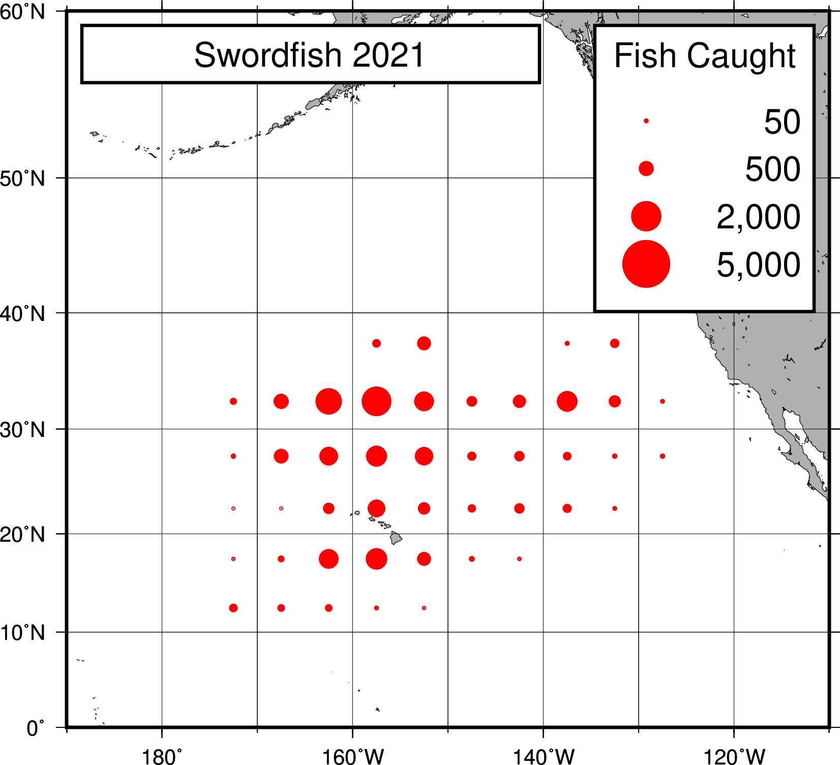

Figure 8.–U.S longline swordfish catch-per-unit-effort (CPUE) in the north Pacific Ocean, 1991-2021.



Figure 9a.–Quarterly U.S. longline shallow-set swordfish CPUE, 1991-2021.



Figure 9b.–Quarterly U.S. longline deep-set swordfish CPUE, 1991-2021.



Figure 10a.–U.S. longline shallow-set swordfish weight-frequency, 2021.



Figure 10b.–U.S. longline deep-set swordfish weight-frequency, 2021.



1. PIFSC Working Paper WP-22-04. Issued November 2022

   Working document submitted to the Swordfish Working Group for the International Scientific Committee for Tuna and Tuna-like Species (ISC), Billfish Working Group, November 28-30, 2022, Yokohama, Japan. Document not to be cited without authors’ permission.